**R Code for Examples in the book**

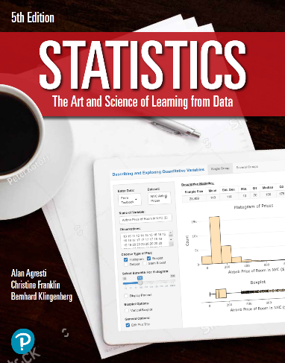

***“Statistics: The Art and Science of Learning from Data”***

**by Agresti, Franklin and Klingenberg, 5th edition**

**Chapter 8**

**Example 4: Influenza Vaccine – 99% Confidence Interval**

## Reading in sample proportion data

x <- 26  
n <- 3900  
phat <- x / n

## To compute the standard error

se <- sqrt(phat * (1 - phat) / n)  
se

## [1] 0.001303075

## To compute the margin of error for a confidence level of 99%

zscore <- qnorm(0.995)  
me <- zscore * se  
me

## [1] 0.0033565

## To compute the 99% confidence interval for the population proportion

phat + c(-1, 1) * me

## [1] 0.003310167 0.010023167

## To compute the margin of error for a confidence level of 95%

zscore <- qnorm(0.975)  
me <- zscore * se  
me

## [1] 0.002553981

## To compute the 99% confidence interval for the population proportion

phat + c(-1, 1) * me

## [1] 0.004112686 0.009220648